**Build a Real-Time Webcam Streaming Server in Rust with OpenCV**

[[Zacchaeus Oluwole](https://medium.com/@zacchaeusoluwole?source=post_page-----65b4d57cd22f--------------------------------)](https://medium.com/@zacchaeusoluwole?source=post_page-----65b4d57cd22f--------------------------------)

[Zacchaeus Oluwole](https://medium.com/@zacchaeusoluwole?source=post_page-----65b4d57cd22f--------------------------------)

·

Follow

4 min read

·

Sep 10

53

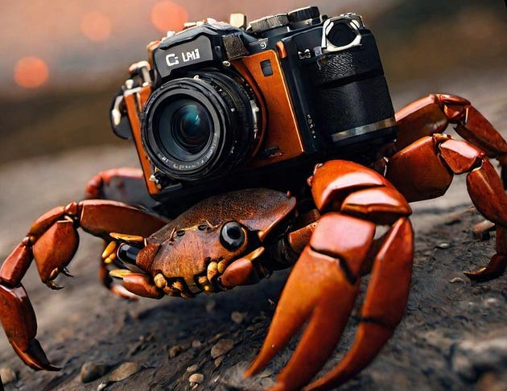

In today’s rapidly evolving technological landscape, real-time multimedia streaming has become an integral part of our digital experience. Whether it’s video conferencing, live streaming, or remote surveillance, the ability to capture and stream video frames in real-time is a powerful capability. In this article, we’ll explore how to build a simple real-time webcam streaming server using Rust and the OpenCV crate.

**Prerequisites**

Before we dive into the implementation, make sure you have Rust and the necessary dependencies installed:

1. Rust programming language: [Install Rust](https://www.rust-lang.org/tools/install)
2. OpenCV Rust Bindings: Install [Opencv Crate](https://crates.io/crates/opencv) or Add opencv to your Cargo.toml dependencies.

**The Concept**

Our goal is to create a server that captures frames from a webcam and streams them over HTTP in real-time to connected clients. We’ll utilize the OpenCV crate for webcam interaction and image processing.

**Setting Up the Server**

Let’s break down the implementation step by step:

1. Importing Dependencies

We start by importing the required crates:

The code begins by importing necessary dependencies from the OpenCV crate and standard Rust crates. The OpenCV crate is used for image and video processing.

use opencv::{  
 core::{Mat, Vector}, imgcodecs, prelude::*, videoio,  
};  
  
use std::net::TcpListener;  
use std::io::Write;

2. Binding TCP Listener: The code binds a TCP listener to the IP address “192.168.83.144” and port “8080” using the TcpListener::bind function. This sets up the server to listen for incoming client connections on this IP and port.

fn main() {  
 // Remember to change this IP address to your localhost or connected network IP address  
 // Replace the 192.168.83.144 with 127.0.0.1 or any  
 let listener = TcpListener::bind("192.168.83.144:8080").unwrap();  
 println!("Server listening on port 8080");  
//...  
}

3. Initializing Camera : The code initializes a video capture object (cam) to capture frames from the default webcam (device index 0) and set up the main loop.

fn main(){  
 // ... (previous code)  
 let mut cam = videoio::VideoCapture::new(0, videoio::CAP_ANY).expect("Failed to get video capture");  
 let mut frame = Mat::default();  
 let mut buf = Vector::new();  
 loop{  
 // ... (rest of the code)  
 }  
}

4. Main Loop: The above code enters a main loop, where it continuously listens for incoming client connections and serves them with live video frames.

5. Accepting Client Connection: Inside the loop, the server waits for a client to connect using the listener.accept() function. Once a connection is established, it returns a TCP stream (stream) that will be used to communicate with the client.

loop {  
 let (mut stream, _) = listener.accept().expect("Failed to accept connection");  
 //... Rest of the code  
}

6. Capturing and Encoding Frame: After establishing a connection, the code reads a video frame from the webcam using the cam.read(&mut frame) function. The captured frame is then encoded into a JPEG image using the imgcodecs::imencode function. The encoded image data is stored in the buf vector.

cam.read(&mut frame).expect("Failed to capture frame");  
buf.clear();  
let _ = imgcodecs::imencode(".jpg", &frame, &mut buf, &Vector::new());

7. Creating Response Header: The code creates an HTTP response header with a content type of “multipart/x-mixed-replace” and specifies a boundary called “frame.” This header indicates that multiple image frames will be sent sequentially. This allows clients to receive and display the frames in real-time without needing to close and reopen the connection for each new frame.

let response = format!(  
 "HTTP/1.1 200 OK\r\nContent-Type: multipart/x-mixed-replace; boundary=frame\r\n\r\n"  
);  
  
stream.write_all(response.as_bytes()).unwrap();

8. Sending Response Header: The response header is written to the client’s stream using the stream.write_all function. This informs the client that the server is ready to send image frames.

9. Inner Loop for Streaming Frames: Inside a nested loop, the server continuously captures frames, encodes them, and sends them to the client in a continuous stream. This loop ensures that new frames are captured and sent as soon as they are available.

loop {  
 cam.read(&mut frame).expect("Failed to capture frame");  
 buf.clear();  
 let _ = imgcodecs::imencode(".jpg", &frame, &mut buf, &Vector::new());  
  
 let image_data = format!(  
 "--frame\r\nContent-Type: image/jpeg\r\nContent-Length: {}\r\n\r\n",  
 buf.len()  
 );  
  
 stream.write_all(image_data.as_bytes()).unwrap();  
 stream.write_all(buf.as_slice()).unwrap();  
 stream.write_all(b"\r\n").unwrap();  
 stream.flush().unwrap();  
}

10. Encoding and Sending Frames: Within the inner loop, the server again captures a frame, encodes it, and stores the encoded data in the buf vector. It then constructs an HTTP response with appropriate content type and content length headers for the image. The image data is sent to the client's stream using the stream.write_all function.

11. Flushing Stream: After sending the image data, the server flushes the stream using stream.flush() to ensure that the data is sent immediately to the client.

12. Run: Enter “cargo run” in the terminal to run the program, then open the browser and enter the IP address(e.g. 192.168.83.144:8080 ) to start streaming.

Get the complete code [here](https://github.com/Zacchaeus-Oluwole/RUST-PROJECTS/blob/main/real-time_webcam_streaming_server/rcvweb/src/main.rs)

**Conclusion**

Congratulations! You’ve successfully built a real-time webcam streaming server using Rust and the OpenCV crate. This project demonstrates the power and flexibility of Rust in combination with powerful crates to create practical applications. You can further enhance this server by adding features like authentication, multiple camera support and client, or integrating it with web interfaces.

Real-time streaming is just one of the many exciting possibilities that Rust and OpenCV enable. By mastering these tools, you can explore a wide range of multimedia applications, from computer vision to video processing and beyond. Happy coding!